4. The Architectural Styles Defining Naples Luxury Homes

SEO Title
Luxury Home Architecture Styles in Naples Florida

Meta Description
Explore the most popular luxury home architecture styles shaping Naples real estate, from West Indies-inspired estates to modern coastal design.

Target Keywords
Naples luxury architecture, modern coastal homes Naples, West Indies homes Naples, luxury home design Naples FL

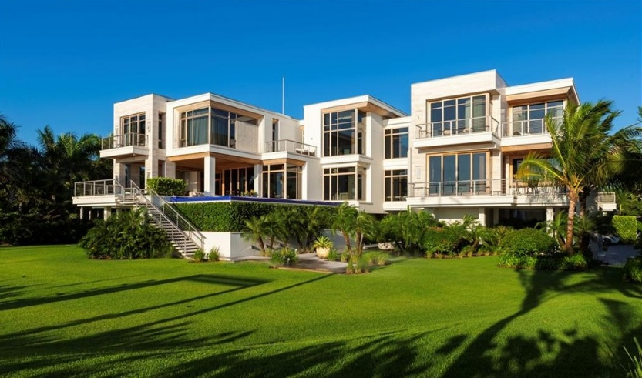

Internal Linking Opportunities
- New construction homes page
- Luxury home gallery
- Port Royal modern homes page

Suggested CTA
Looking for a luxury home that matches your style? Contact Michael Giacalone at Premier Sotheby’s International Realty for private market insights and available listings. 239.431.0321

Where Coastal Elegance Meets Modern Design
Luxury real estate in Naples showcases an impressive range of architectural styles, each reflecting the city’s evolution and coastal character.
Traditional West Indies-inspired homes remain among the most popular styles in waterfront communities like Port Royal and Old Naples. These residences often feature expansive covered lanais, large windows, natural wood accents, open floor plans, and seamless indoor-outdoor living.
Modern coastal architecture has also surged in popularity in recent years. Buyers are increasingly drawn to sleek contemporary homes with clean lines, floor-to-ceiling glass, dramatic lighting, and minimalist finishes. These homes are designed to maximize water views while creating bright, open spaces filled with natural light.
Mediterranean-inspired estates continue to maintain strong appeal as well. Known for grand entrances, detailed stonework, barrel tile roofs, and resort-style courtyards, these homes offer timeless elegance and sophistication.
One of the most unique aspects of Naples architecture is the way homes are designed around lifestyle. Outdoor entertaining spaces are often just as important as interior living areas. Features like infinity-edge pools, rooftop terraces, private docks, wine rooms, wellness spaces, and guest casitas have become increasingly common.
As buyer preferences evolve, builders and architects continue pushing the boundaries of luxury home design while preserving the relaxed coastal atmosphere that makes Naples special.
Whether buyers prefer classic elegance or contemporary sophistication, Naples offers architectural diversity rarely found in other luxury coastal markets.

